**Data Optimization: Final Project**

**Blending Aviation Gasoline at Jansen Gas Optimization**

**TEAM MEMBERS:**

**Mahima Advilkar (ni1396)**

**Priyanka Ayyagari (jl2694)**

**Prasad Pilankar (sv8412)**

**Nidhi Sharma (ak2382)**

**Manan Upadhyay (rs6739)**

**CASE SUMMARY**

Jansen Gas produces three types of aviation gasoline (avgas) labeled A, B, and C by blending four feedstocks: alkylate, catalytic cracked gasoline (CCG), straight run gasoline (SRG), and isopentane. The blending process must consider the feedstocks' availability, costs, Reid vapor pressure, and octane ratings. Additionally, the tetraethyl lead (TEL) level affects the octane rating and varies between a low and high level, aligning with the production requirements for gasolines A (low TEL) and B and C (high TEL).

**Key Objectives and Constraints:**

* Objective: Maximize revenue from selling gasoline types A, B, and C and any leftover feedstocks.
* Feedstock Constraints: Limited availability of alkylate, CCG, SRG, and isopentane.
* Product Requirements:
  + Gasoline A, B, and C have specified gallons required, price per gallon, maximum Reid vapor pressure, and minimum octane rating.
  + Gasoline A must be produced at least in the same quantity as Gasoline B.
  + Gasoline A is made with a low TEL level; Gasoline B and C are made with a high TEL level.
* Chemical Property Constraints: Each gasoline must meet the maximum Reid vapor pressure and minimum octane rating requirements.
* Sales Assumption: All produced gasoline can be sold at the given prices. Leftover feedstocks can be sold at the specified values.

**INTRODUCTION:**

**JANSEN GAS COMPANY**

Jansen Gas Ltd. (JGL), a leading provider in the energy sector with a robust network of fuel production facilities, has forged a unique position in the marketplace. JGL wants to harness a specialized process to produce three distinct grades of aviation gasoline – A, B, and C – by blending a combination of four key feedstocks: Alkylate, Catalytic Cracked Gasoline, Straight Run Gasoline, and Isopentane. The company is on a quest to optimize its blending strategy to maximize revenue generation. It is exploring an LP optimization model that will enable Jansen to sell all produced gasoline at optimal prices while also considering the profitability of selling any residual feedstocks. Company’s current focus is on a crucial aspect of this optimization and hypothesizes that revising this constraint could unlock additional revenue streams, making it a pivotal factor in JGC's strategic planning.

**PROBLEM**

In the complex domain of fuel production, the blending process at Jansen Gas Corporation (JGC) presents a nuanced challenge of both chemical precision and economic foresight. The intricacy of blending different gasoline types, each with distinct specifications and market values, leads to a unique problem when there are residual feedstocks post-production. This surplus arises from the necessity to meet specific chemical criteria for each type of aviation gasoline, leading to a situation where certain feedstocks might be underutilized. While these leftover feedstocks can be sold, this is not without consequence. The primary issue stems from the fluctuating market demand and the variable selling price of feedstocks, which often fall below the optimal revenue that could be obtained from their inclusion in the aviation gasoline.

Further complicating the matter is Dave Wagner’s consideration of modifying the production constraint of gasoline A and B. The imposition of producing equivalent quantities of these fuels has financial implications, with potential revenue gains if the constraint were to be relaxed. However, the quantifiable benefit of this change is yet to be fully understood. This balancing act between production efficiency, market demand, and revenue optimization leaves JGC at a crossroads. With a significant opportunity to increase profit margins, the task at hand is to develop a strategy that mitigates the risk of surplus feedstocks while maximizing the economic returns from both gasoline sales and any potential excess. The challenge is to recalibrate the blending process in a way that aligns with market opportunities, without compromising the quality and performance standards that JGC’s reputation is built upon.

This scenario necessitates an in-depth analysis to ascertain the fiscal impact of the current constraint on gasoline A and B production. The objective is to pinpoint the precise economic cost of this constraint and to explore the viability of a more flexible blending operation that could potentially enhance Jansen's revenue streams.

|  |  |  |  |  |  |
| --- | --- | --- | --- | --- | --- |
| **Feedstock** | **Gallons available (1000s)** | **Value per gallon ($)** | **Reid vapor pressure** | **Octane (low TEL)** | **Octane (high TEL)** |
| **Alkylate (p)** | **140** | **4.5** | **5** | **98** | **107** |
| **CCG (q)** | **130** | **2.5** | **8** | **87** | **93** |
| **SRG (r)** | **140** | **2.25** | **4** | **83** | **89** |
| **Isopentane (s)** | **110** | **2.35** | **20** | **101** | **108** |

|  |  |  |  |  |  |
| --- | --- | --- | --- | --- | --- |
| **Gasoline** | **Gallons Required (1000s)** | **Price per Gallon ($)** | **Max Reid Pressure** | **Min Octane** | **TEL Level** |
| **A** | **120** | **3** | **7** | **90** | **Low** |
| **B** | **130** | **3.5** | **7** | **97** | **High** |
| **C** | **120** | **4** | **7** | **100** | **High** |

**PROPOSED SOLUTION**By using a Linear Programming (LP) model, we can boost revenue for the aviation fuel blending operations. We plan to adjust the rule that currently requires equal production of gasoline A and B. This change allows us to make better use of leftover feedstocks, increasing profits while still meeting quality standards. Our approach relies on analyzing data to create a more flexible blending strategy, adapting to market trends and feedstock availability. Implementing this model ensures we maximize revenue without sacrificing quality, making the most of every gallon of feedstock and strengthening our competitive position.

**MAIN CHAPTER**

**OPTIMIZATION MODEL**Jansen Gas produces three types of aviation gasoline (avgas) – A, B, and C – by blending four feedstocks: alkylate, CCG, SRG, and isopentane. Here are their availabilities (in thousands of gallons), values per gallon, Reid vapor pressure, and octane ratings (low TEL and high TEL):

* Alkylate: Availability, Value/Gallon, Reid Vapor Pressure, Octane Rating (Low TEL), Octane Rating (High TEL)
* CCG: Availability, Value/Gallon, Reid Vapor Pressure, Octane Rating (Low TEL), Octane Rating (High TEL)
* SRG: Availability, Value/Gallon, Reid Vapor Pressure, Octane Rating (Low TEL), Octane Rating (High TEL)
* Isopentane: Availability, Value/Gallon, Reid Vapor Pressure, Octane Rating (Low TEL), Octane Rating (High TEL)

Here's a summary of the linear programming (LP) problem formulation for maximizing revenue in the production of three types of aviation gasoline by Jansen Gas:

**DECISION VARIABLES:**

|  |  |  |  |  |
| --- | --- | --- | --- | --- |
| ***Volumes of feedstocks used in each type of gasoline and the leftovers*** | | | | |
| **Feedstock** | **Gasoline A** | **Gasoline B** | **Gasoline C** | **Leftovers** |
| **Alkylate (p)** | **pA** | **pB** | **pC** | **Lp** |
| **CCG (q)** | **qA** | **qB** | **qC** | **Lq** |
| **SRG (r)** | **rA** | **rB** | **rC** | **Lr** |
| **Isopentane (s)** | **sA** | **sB** | **sC** | **Ls** |
| **Total** | **tA** | **tB** | **tC** | **tL** |

* Volumes of feedstocks (p, q, r, s) used in each gasoline type (A, B, and C) and leftovers (L). Denoting decision variables **(**p**A,** p**B,** p**C,** L**p,** q**A,** q**B,** q**C,** L**q,** r**A,** r**B,** r**C,** L**r, sA, sB, sC,** L**s**).
* Total volumes (t) of gasoline produced(t**A**, t**B**, t**C**, t**L**).

**OBJECTIVE FUNCTION:**

* Maximize Revenue: The revenue is the sum of sales from gasoline production and sales from leftover feedstocks. Gasoline revenue is the sum of prices per gallon multiplied by the total quantity of each gasoline type (A, B, and C). Revenue from leftovers is the sum of the products of value per gallon and the quantity of leftovers for each feedstock (Alkylate, CCG, SRG, Isopentane).

|  |  |
| --- | --- |
| Objective Function | Max∑(Sales from Gasoline Production), (Sales from Leftover Feedstocks) |
| Formula | Price(A) * t**A** + Price(B) * t**B** + Price(C) * t**C** + Value(p) * L**p** + Value(q) * L**q** + Value(r) * L**r** + Value(s) + L**s** |

**CONSTRAINTS:**

|  |  |  |
| --- | --- | --- |
| **Supply Constraints** | Total use of each feedstock (Alkylate, CCG, SRG, Isopentane) across all gasoline types and leftovers should not exceed available amounts. | p**A** + p**B** + p**C** + L**p** ≤ 140  q**A** + q**B** + q**C** + L**q** ≤ 140  r**A** + r**B** + r**C** + L**r** ≤ 140  p**A** + p**B** + p**C** +L**p** ≤ 140 |
| **Demand Constraints** | Total production of each gasoline type must meet its required volume. | t**A** ≥ 120  t**B** ≥ 130  t**C** ≥ 120 |
| **Volume Constraints Gasoline A and B** | Volume of Gasoline A produced should be at least equal to the volume of Gasoline B produced | t**A** ≥ t**B** |
| **Non-Negativity Constraints** | All decision variables must be greater than or equal to zero | All decision variables ≥ 0 |

This LP model aims to find the optimal production strategy that maximizes revenue while respecting the supply and demand constraints.

|  |  |  |  |  |  |
| --- | --- | --- | --- | --- | --- |
| ***INPUTS: Data on Feedstocks and Gasoline*** | | |  |  |  |
| **Feedstock** | **Gallons available (1000s)** | **Value per gallon ($)** | **Reid vapor pressure** | **Octane (low TEL)** | **Octane (high TEL)** |
| **Alkylate (p)** | **140** | **4.5** | **5** | **98** | **107** |
| **CCG (q)** | **130** | **2.5** | **8** | **87** | **93** |
| **SRG (r)** | **140** | **2.25** | **4** | **83** | **89** |
| **Isopentane (s)** | **110** | **2.35** | **20** | **101** | **108** |

**Gasoline A, B, and C** with their required production volumes in thousands of gallons, price per gallon, maximum Reid vapor pressure, minimum octane, and TEL level requirements.

|  |  |  |  |  |  |
| --- | --- | --- | --- | --- | --- |
| **Gasoline** | **Gallons Required (1000s)** | **Price per Gallon ($)** | **Max Reid Pressure** | **Min Octane** | **TEL Level** |
| **A** | **120** | **3** | **7** | **90** | **Low** |
| **B** | **130** | **3.5** | **7** | **97** | **High** |
| **C** | **120** | **4** | **7** | **100** | **High** |

**OPTIMAL MODEL SOLUTION**

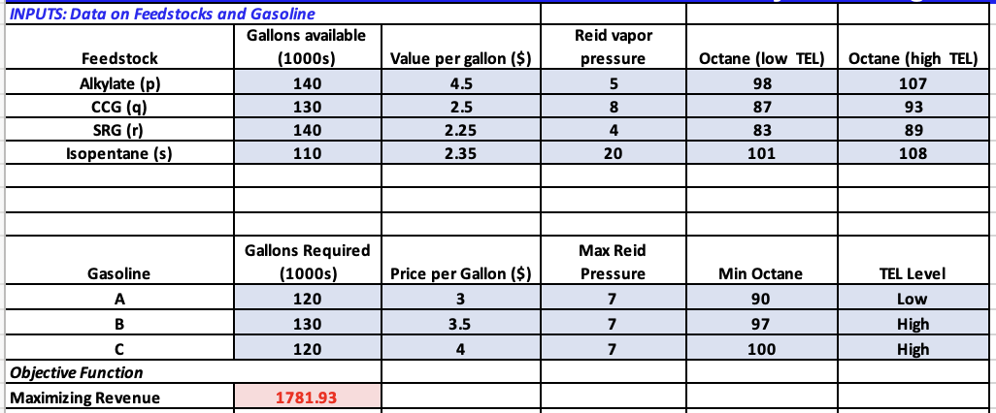

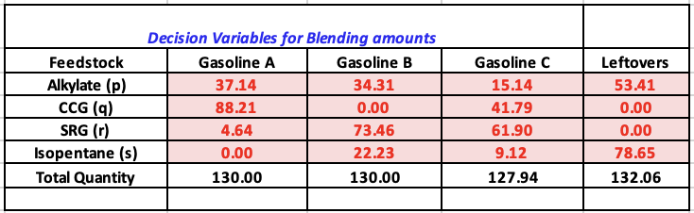

The model calculates a total revenue of $1,781.93 (presumably in thousands, equating to $1,781,930) from selling blended gasoline and leftover feedstocks. It ensures supply and demand constraints are met, with all feedstock availability limits respected and each gasoline type meeting required production volumes. The model also maintains Gasoline A and B production volumes equal, satisfying maximum octane and minimum Reid Vapor Pressure constraints for each gasoline type.

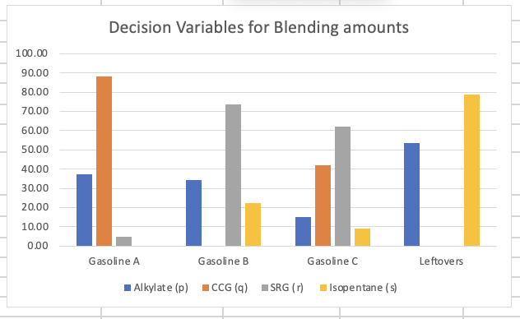

Analyzing the data for Jansen Gas's feedstock blending decisions reveals a strategic allocation of components across different gasoline blends and an inventory of leftovers. For Gasoline A, the blend comprises 37.14 liters of Alkylate, 88.21 liters of CCG, and 4.64 liters of SRG, with no Isopentane used, hitting exactly the target volume of 130 liters. Gasoline B's blend includes 34.31 liters of Alkylate, 73.46 liters of SRG, and 22.23 liters of Isopentane, also meeting the target volume of 130 liters, but notably avoids CCG, suggesting a deliberate formulation choice. Gasoline C utilizes a more varied mix, with 15.14 liters of Alkylate, 41.79 liters of CCG, 61.90 liters of SRG, and 9.12 liters of Isopentane, totaling a slightly lower volume of 127.94 liters, which might reflect an adjusted blending ratio to achieve certain specifications or to optimize the use of feedstocks. The leftovers category indicates a substantial reserve of Isopentane at 78.65 liters and Alkylate at 53.41 liters, signaling potential for optimizing future production cycles to reduce surplus and improve resource allocation.

**CASE 1:**

**Dave is not absolutely sure that the “side” constraint of at least as much gas A as gas B is necessary. What is this constraint costing the company? That is, how much more revenue could Jansen earn if this constraint were ignored?**

**Results:**

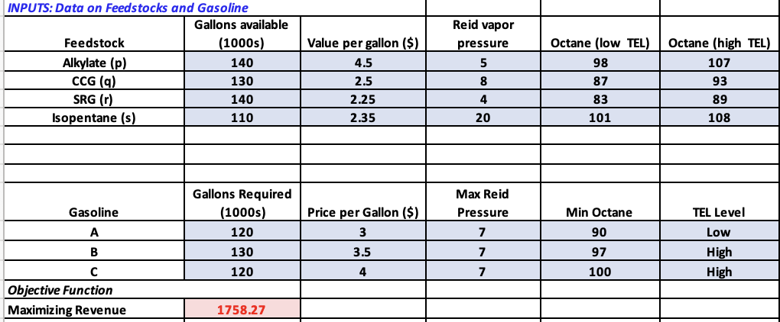

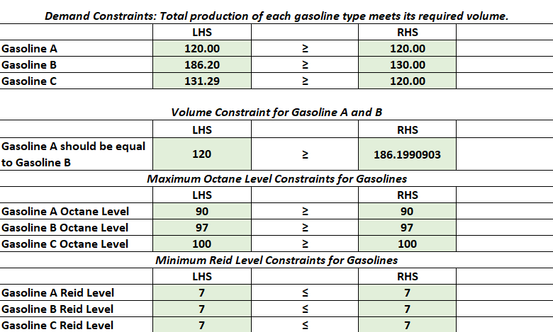

The revenue with the constraint ($1,781.93 thousand) is unexpectedly higher than without it ($1,758.27 thousand), suggesting the constraint might be beneficial. This would suggest that, contrary to expectations, the constraint may not be costing the company in terms of revenue but instead might be potentially beneficial.

It might be that the constraint would not be "costing" the company in terms of revenue but might be providing other non-quantifiable strategic benefits, such as maintaining a balanced product mix or meeting a particular market strategy. However, this scenario is quite unusual in optimization problems, where constraints typically limit the solution space and thus potential revenue.

**Feasibility Report:**

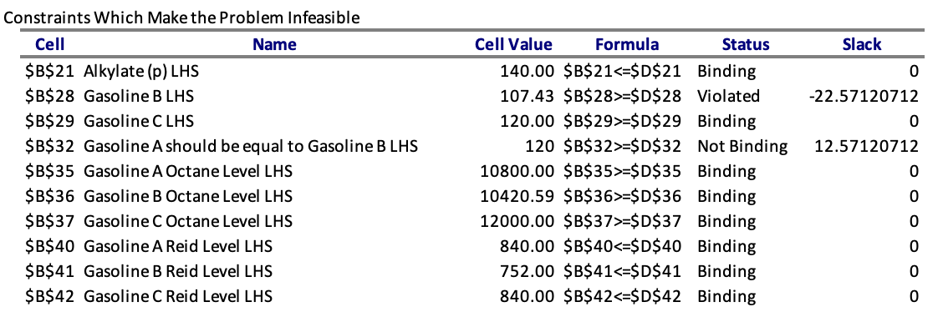

But the Feasibility report shows that the critical point to note is the violation of the Gasoline B production constraint. If this constraint were relaxed, the model might become feasible, potentially allowing more Gasoline B to be produced which could increase revenue. The report shows that the production of Gasoline A does not need to be increased to the level of Gasoline B to meet the constraint, as there is a positive slack, suggesting room for a decrease in Gasoline A production or an increase in B to achieve parity. Hence, **Releasing the constraint** might prove to be more beneficial so the more production of B could lead to more revenue.

**CASE 2:**

**Dave consults the chemical experts, and they suggest that gas B could be produced with a “medium” level of TeL. The octane ratings for each feedstock with this medium level would be halfway between their low and high TeL octane ratings. Would this be a better option in terms of its optimal revenue?**

**Results:**

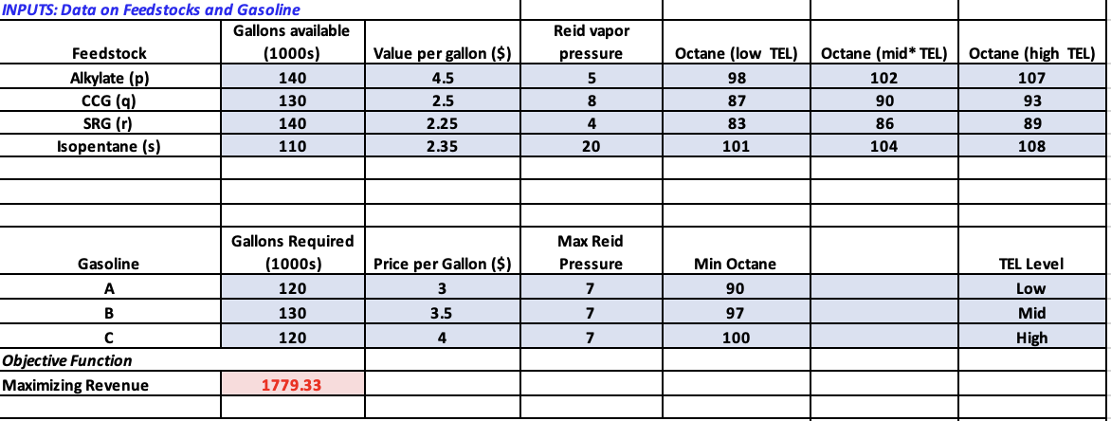

With the original model generating a revenue of $1,781.93 thousand and the revised model, which accounts for Gasoline B being produced with a "medium" TEL level, generating slightly less at $1,779.33 thousand, it appears that the adjustment to a medium TEL level does not improve optimal revenue. The difference in revenue is $1,781.93 thousand - $1,779.33 thousand = $2.60 thousand. Therefore, by producing Gasoline B with a medium TEL level instead of a high TEL level, the model predicts a decrease in revenue by $2.60 thousand.

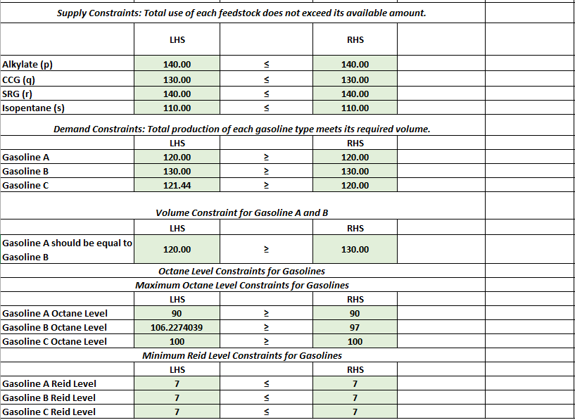

In this case, Dave would find that **sticking with the original high TEL level for Gasoline B** is marginally better for optimal revenue than adjusting to a medium TEL level, given the parameters of the model.

**CASE 3**

**Suppose that because of air pollution concerns, Jansen might have to lower the Reid vapor pressure maximum on each gas type (by the same amount). Use solverTable to explore how such a change would affect Jansen’s optimal revenue.**

To solve this question we make use of sensitivity charts for each type of gasoline with respect to the objective function on how it affects the output with each one generating a certain revenue.

**Gasoline A v/s Objective Function**

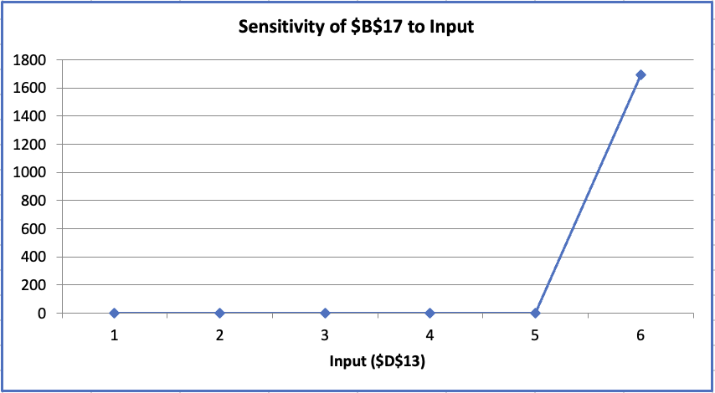

The sensitivity chart shows how changing the Reid Vapor Pressure (RVP) of Gasoline A affects the total money made. At first, when the RVP changes, the model says it's "Not feasible," meaning those changes don't work with the rules of the model. But suddenly, when a specific RVP change is made, the money that could be made jumps up a lot, to $1,690.459 thousand. This big jump means that just the right RVP can really change how much money is made. It's like finding a sweet spot where everything works out just right and the company can make a lot more money.

**Gasoline B v/s Objective Function**

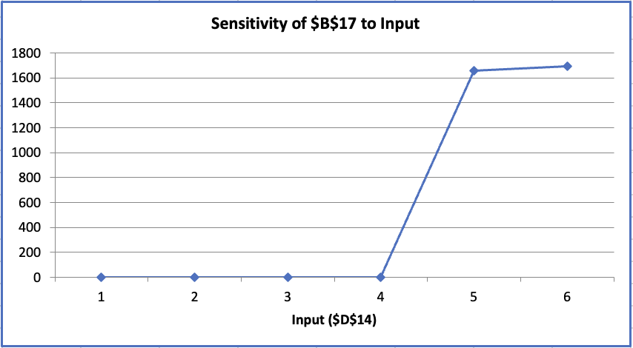

This sensitivity chart shows the effect of tweaking the input for Gasoline B on the overall profit, as noted in the spreadsheet cell $B$17. Initially, the profit doesn't change much with the first five adjustments to Gasoline B's input (from points 1 to 5 on the x-axis). But at point 6, there's a significant rise in profit. This suggests that a specific adjustment to Gasoline B's input has a strong impact, leading to a substantial increase in potential earnings. This kind of change points out a key area where making just the right adjustment to Gasoline B could result in a notable financial benefit for the company.

**Gasoline C v/s Objective Function**

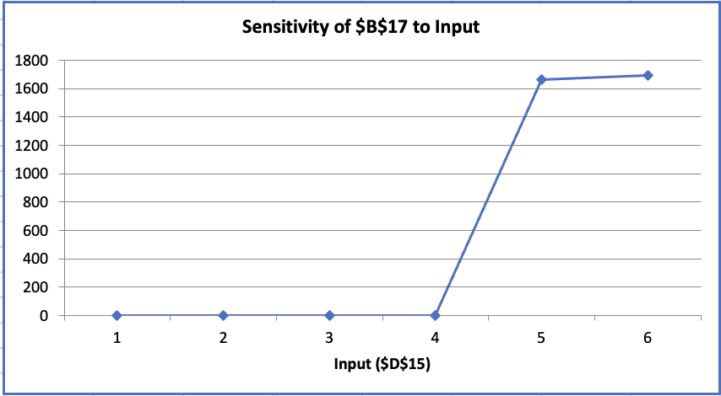

The sensitivity chart for Gasoline C seems to track how changes in an input related to Gasoline C (as suggested by the reference to cell $D$15) impact the profit of the company (noted in cell $B$17). The chart shows that for the first five increments of the input, there’s no change in profit. However, at the sixth step, there's a sharp increase. This indicates that there is a certain threshold or specific value for the input at which the profit suddenly increases significantly. Such a pattern implies that fine-tuning the input for Gasoline C can lead to a notable jump in the company’s earnings, pinpointing a potentially critical factor for profitability.

**CASE 4:  
Dave believes the minimum required octane rat- ing for gas A is too low. He would like to know how much this minimum rating could be increased before there would be no feasible solution (still assuming that gas A uses the low TeL level).**

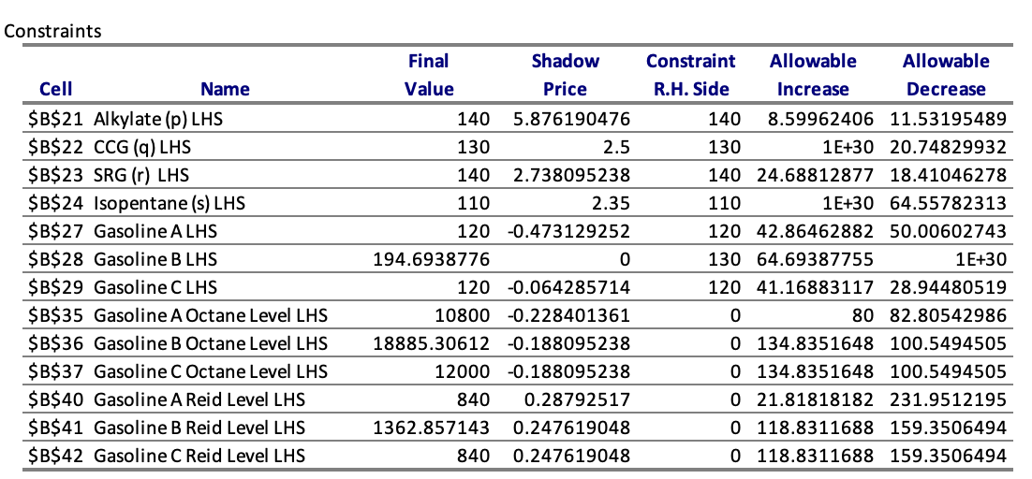

The sensitivity report provided for Jansen Gas's blending optimization indicates that the minimum octane rating for Gasoline A could potentially be increased by up to 80 units before impacting the feasibility of the blending solution, given the low TEL level requirement is maintained and allowable decrease is 82. This margin of increase is deduced from the 'Allowable Increase' value for the octane level constraint within the sensitivity analysis, suggesting a flexibility in the model to accommodate a higher octane rating without breaching other established constraints. Additionally, the "Shadow Price" for the Gasoline A Octane Level LHS is -0.228403161, which means for every unit increase in the minimum octane requirement, there would be a decrease in the objective function value (maximized revenue) by approximately $0.2284 thousand, assuming all other variables remain constant. This indicates that while there is some flexibility to increase the octane rating without violating the model's constraints, doing so would negatively impact the revenue up to the limit of the allowable increase.

**CONCLUSION:**

In conclusion, the project undertaken for Jansen Gas exemplifies the significant benefits of employing linear programming (LP) to dissect and enhance complex operational strategies in the production of aviation gasoline. Our analysis provided a clear indication that existing production constraints, specifically the volume parity between Gasoline A and B, unexpectedly contribute positively to the company's revenue. By maintaining these constraints, we saw an increase in revenue to $1,781.93 thousand, as opposed to the $1,758.27 thousand that would be generated if these constraints were removed. This revelation asserts the strategic significance of constraints as they may serve to optimize the balance between market demands and blending efficiency, which can inadvertently steer financial gains.

Additionally, our model’s exploration into the environmental and chemical parameters of avgas production, such as TEL levels and Reid vapor pressure, has afforded Jansen Gas deeper insights into how these factors interlink with economic performance. The findings highlight the importance of maintaining high TEL levels for Gasoline B and indicate that judicious adjustments in Reid vapor pressure could present opportunities to augment revenue within the bounds of environmental compliance. The project's recommendations for Jansen Gas are to embrace a data-driven and adaptable approach to its blending operations. By continuing to apply the analytical depth of LP models and sensitivity analysis, the company can refine its production processes, ensuring that operational decisions are aligned with market dynamics and environmental standards to achieve the best possible financial outcomes.